Fast**National University of Computer & Emerging Sciences, Karachi  
Fall-2021 CS-Department  
Assignment 2**

**Deadline 5 April 2020 2:00 pm – 3:00 pm**

|  |  |
| --- | --- |
| **Course Code: CS301** | **Course Name: Theory of Automata** |

**Question 1:**

**10 points**

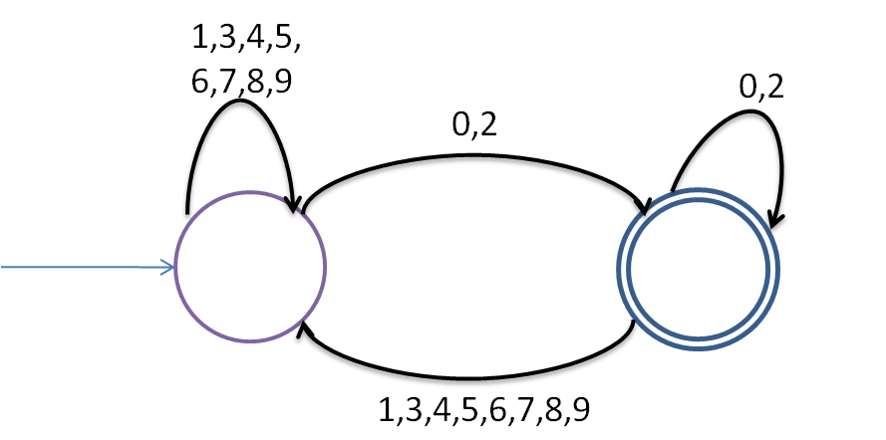

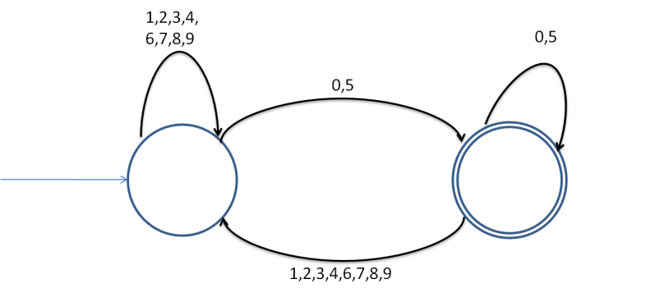

p0

p1

DFA2: Divisible by 2

q0

q1

DFA1: Divisible by 5

1. **Given two DFA's DFA1 and DFA2 find the union DFA1 U DFA2 to find** **DFA10. What language does DFA 10 accepts?**
2. **Minimize DFA10.**

**Question 2:**

**Convert the following NFA to DFA:**

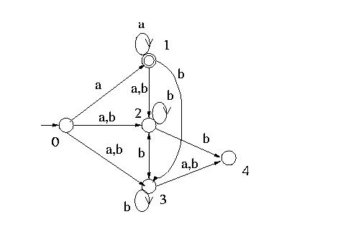

**Question 3:**

**Convert the following epsilon NFA to DFA:**

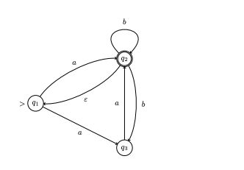

**Question 4: (Concatenation, union and closure Of DFA)**

1. **Find the Concatenation of FA1 and FA2 given in figure 3 and figure 4.**
2. **Find the Concatenation of FA1 and FA2 given in figure 3 and figure 4.**
3. **Find the closure of FA1 given in figure 3.**

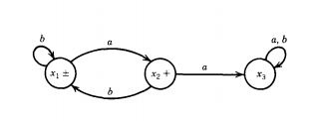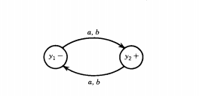

**Figure 3 Figure 4**

**Note : Show steps of your method properly to get full credit.**

**Question 5:**

**Find the minimal DFA of the following.**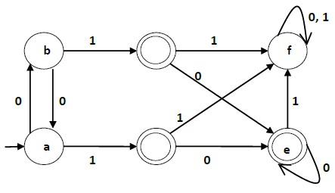

**Question 6:**

**Property of regular expression**

**Take any two regular expression of any language draw their NFA and show me properties of regular expression.**

**Ex**

* **union of two NFA or l1 or l2**
* **Concatenation of two NFA**
* **Star OF Language**
* **Reversal of language**
* **complement of language**

***BEST OF LUCK!***